Time-sheets interface   
JIRA-TEMPO / SCIFORMA

Functional specification

# History

|  |  |  |  |
| --- | --- | --- | --- |
| Author | Date | Rev # | Comments |
| OCH | 26/09/2018 | 1 | First Draft |
| VPO | 11/10/2018 | 2 | Reviewed and commented version |
| OCH | 11/10/2018 | 3 | Answers and comments |
| OCH | 15/10/2018 | 4 | Final for quotation request |

# Actions and validations

|  |  |  |  |  |
| --- | --- | --- | --- | --- |
| Entity | Represented by | Action | Date | Comment – OK /NOK |
| PPM Tooling | O. CHOQUET | Write | 03/10/18 | Done |
| Business Support | A MAENNEL | Review, go for quotation | 03/10/18 | OK |
| Business | B. ROBB | Review, go for quotation | 15/10/18 | OK |
| Finance | E. PICOU | Review, go for quotation |  |  |
| R&D | P. SALIGNAT | Review, go for quotation | 12/10/18 | OK |
| JIRA Team | V. POCHARD | Review, go for quotation | 12/10/18 | OK |
| Sciforma.Net | F. COUSTES | Quotation |  |  |
| PPM Tooling | O. CHOQUET | Finalization of business case |  |  |
| Steering Board | TBD | Decision |  |  |

Please delegate actions and validation if needed.

Table des matières

History 2

Actions and validations 2

Context and general architecture 4

Purpose of the interface 4

Data model 4

Architecture and process 4

Contributors 4

Data exchanges 5

Flow #1. Resource checks 5

Overall process 5

Export 6

Reception 6

Checks 6

Quotation 6

Flow #2. Projects & Tasks checks 7

Export 8

Reception 8

Checks 8

Fixes 8

Quotation 8

Flow #3. Timesheets transfer and checks 9

Overall process 9

Generate and send TS data 10

Reception – Get the export 10

Initial Checks 11

Integration – step #1: TS filling 11

Integration – step #2: TS submission 13

Quotation 15

Global Quotation 15

Opportunities & Risks analysis 15

Opportunities 15

Risks 16

# Context and general architecture

## Purpose of the interface

The purpose of the interface is to transport time-sheet data from JIRA TEMPO, where the capture is made, to Sciforma where it is applied on projects and then sent to SAP.

## Data model

A timesheet entry is defined by:

* Reference to a project in Sciforma
* Reference to the task of the project against which the time is booked
* The date when the effort took place
* The amount of the effort
* Reference to the user doing the time-sheet capture

## Architecture and process

The interface will consist in 3 flows:

* One **Resource** flow, run on request, to ensure the consistency of Resource data between the 3 systems (JIRA / Sciforma / SAP).
* One **Task** flow, run on request too, to ensure the consistency of Project / Task data.
* One **Time-sheet** flow, run for the end of month closing, to check the time-sheet data and to transfer them to Sciforma.

The purpose of the flows 1 & 2 is to anticipate the detection of data inconsistencies between the 3 systems and to allow to fix them before the Finance closing time.

The chart below summarizes the overall process

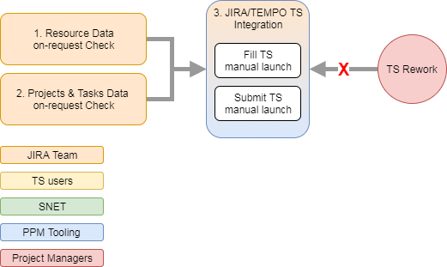

## Contributors

The following naming conventions will be used in this document:

* Sciforma.Net (a.k.a. SNET): team from the company Sciforma in charge of the development and operation of the interface from the hosted Sciforma platform.
* PPM Tools: team from Ingenico in charge of the functional administration of the Ingenico Sciforma platform
* JIRA: team from Ingenico in charge of:
  + The administration of the JIRA instance dedicated to the Tribes and Squad activities follow-up
  + The operation of the interface.
* R&D: teams from Ingenico the timesheets of which will be captured in JIRA and sent to Sciforma.
* Project Managers: persons in charge of managing the project in both Sciforma and JIRA systems.

## Data exchanges

The exchange of data between a system A and a system B is pictured as follows:

1. The system A exports the data to a flat file
2. The file is sent to a repository, accessible from both systems
3. The system B detects the new file and upload it
4. The system B browses the data in the file and process them to import them at the right location.

Any other technical solution could be proposed.

# Flow #1. Resource checks

The purpose of this flow is to detect as soon as possible inconsistencies between JIRA, Sciforma and SAP resource repositories.

It was agreed that the email address will be the ID, common to JIRA and Sciforma, allowing to check that resources are known from both side.

Note: Ingenico is currently implementing SSO for the Sciforma platform. AD’s email addresses will become the login ID for Sciforma as well.

## Overall process

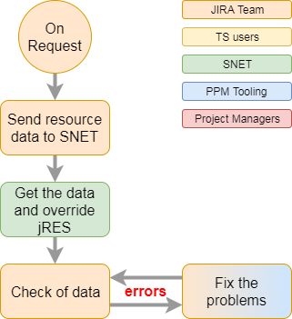

## Export

JIRA will export the file containing the following information:

* ID: email address of the resource
* First name
* Last name
* Date of extraction

The export must contain the list of all resources that would be exported at the next TS transfer.

## Reception

SNET will populate the data view jRES with the rows of the received file.

This data view will contain 4 fields to store the imported data.

* email
* first name
* last name
* extraction date

The loading of the data will flush the data view in the first place.

## Checks

PPM Tools will provide a report in Sciforma that will display all of the received records, and display for each row the following indications:

* Found: *flag indicating whether the email address was found in the Sciforma’s resources list.*
* Active: *flag indicating if the resource is fully / partially / not at all active within Sciforma during the current month.*
* Locked: *flag indicating whether the resource’s organization isn’t locked in Sciforma for the exported month.*
* TS Source: *indicating is* *JIRA or Sciforma is defined in Sciforma as time tracking source.*
* Time Entry Set: *reminds the filling rules for the capture of the timesheet.*

### Fixes

Depending on the nature of the problem either PPM Tools or JIRA will make one of the following fixes:

* Create the resource in Sciforma (required an account creation request to be posted in the help desk)
* Update the resource’s email in Sciforma
* Update the resource’s email in JIRA
* Synchronize the active/inactive status in both systems (The leading system is SAP)
* …

## Quotation

The table below gives a list of the main works to be performed and the associated costs. Each team must fill its parts.

|  |  |  |  |  |
| --- | --- | --- | --- | --- |
| **WID** | **Work** | **Team** | **Cost estimation** | **Comments** |
| 1.1 | Sending of the resource list to Sciforma, on request. | JIRA | N/A |  |
| 1.2 | Data reception and filling of the data view in Sciforma | SNET |  |  |
| 1.3 | Checking report creation | PPM Tooling | 0,5 days |  |

# Flow #2. Projects & Tasks checks

The purpose of this flow is to detect as soon as possible inconsistencies between JIRA and Sciforma projects & tasks repositories. It aims to be sure that the tasks, identified for the JIRA timesheets explicitly exist in Sciforma and can receive timesheet captures.

The SAP code will be used to identify the project and the task will be identified thanks to a text search on its name. JIRA will export identifiers like |FRAARAXI084|AXIN-202|, |FRAARAXI084|AXIN-325|, |FRAARAXI084|AXIN-334| where the AXIN’s # will be part of the name of the task that will receive the timesheet entry.

By convention 5 additional values will be used to send the captures toward non-project activities:

|  |  |  |
| --- | --- | --- |
| **Sent by JIRA** | **Correspondence in Sciforma** | **Description** |
| {empty} | TMP-1 | Non-Project – NPP0012 | Sick-Leave |
| {empty} | TMP-2 | Non-Project – NPP0001 | ABSENCE/DAY-OFF |
| {empty} | TMP-3 | Non-Project – NPP0007 | TRAINING EXTERNAL |
| {empty} | TMP-4 | Non-Project – NPP0006 | TRAINING INTERNAL |
| {empty} | TMP-5 | Non-Project – NPP0004 | MEETINGS (Other than projects) |



## Export

JIRA will export the file containing the following information:

* Project ID: *this is the SAP ID of the project*
* Task ID: *task unique identifier (within the project) allowing to lookup in Sciforma and explicitly find* ***the*** *target task.*
* Extraction date

## Reception

SNET will populate the data view jTASK with the rows of the received file.

The data view will contain 3 fields to store the imported data.

* project SAP ID
* task jID
* extraction date

The loading of the data will flush the data view in the first place.

## Checks

PPM Tooling will provide a report in Sciforma that will display all the received records with for each rows the following controls:

* Project Found: *indicates if the provided SAP ID allows to find one unique project in Sciforma.*
* Project Condition:  *if the project exists in Sciforma its Project Condition will be displayed here. Reminder: the values “On-Hold” or “Closed” will prevent the capture of timesheets onto the project.*
* Task Found: *indicates if the provided Task ID (still to be defined) allows to seek one unique task within the above project in Sciforma. This test could provide 3 different outputs:*
  + *OK: there is only one task existing within the project and having AXIS-XX in its name*
  + *KO Miss: the task wasn’t found*
  + *KO Too many: more than one task with AXIN-XX in the name were found*
* Task Open Status: *indicates whether the task is closed to timesheet captures or open*.
* Task Self Assign Status:  *a warning that will highlight tasks for which the attribute “Allow My Work Add” isn’t set. In this case only timesheets based on Hard Assignments will be allowed; Self Assignments will be rejected.*
* Task Parent Status: indicates whether the task is a parent task (i.e. contains sub-tasks). Timesheet captures are not allowed on parent tasks.

## Fixes

Depending on the nature of the problem the required changes will be processed by the Project Manager either in Sciforma or JIRA.

## Quotation

The table below gives a list of the main works to be performed and the associated costs. Each team must fill the part under its responsibility.

|  |  |  |  |  |
| --- | --- | --- | --- | --- |
| **WID** | **Work** | **Team** | **Cost estimation** | **Comments** |
| 2.1 | Sending the Projects & Tasks file to Sciforma | JIRA | N/A |  |
| 2.2 | Data reception and filling of the data view in Sciforma | SNET |  |  |
| 2.3 | Creation of the checking report | PPM Tooling | 0,5 days |  |

# Flow #3. Timesheets transfer and checks

This step consists in sending the JIRA’s timesheet data to a temporary area, to make the ultimate checks and give a Go / NoGo for the integration toward the Sciforma built-in time-tracking process.

Most of the errors should be avoided thanks to the 2 previous checks but some final checks must be done. These checks deal with the Finance requirements and the Sciforma’s time tracking built-in process.

* Finance requirements
  + All Timesheets must have 5 man-days a week. Some exceptions exist and will be managed as such (not blocking).
  + Each daily timesheet capture must sum-up 1 and only 1 man-day per day.
  + Dates for timesheet captures must be compliant with the resource’s master data in SAP (**Start Date** and **End Date**).
* Sciforma Time Tracking requirements
  + Resources must be part of the project team and – if applicable – of the work-package’s performing organization.
  + If the task is protected against self-assignments, the resource must be already assigned to the task.
  + Globally the resource must be authorized to capture time against the task by the default access right policies setup in Sciforma.

## Overall process

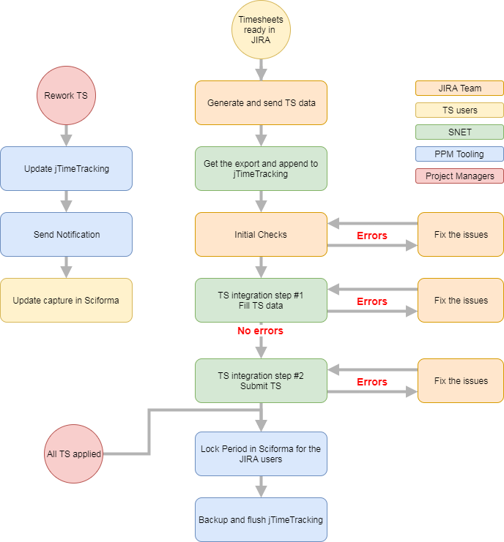

## Generate and send TS data

JIRA will export the file containing the following information:

* Project ID: *ID of the project which the timesheet capture is done against*
* Task ID: *ID of the task which the timesheet capture is done against*
* Resource email: *the email address of the resource for which the timesheet capture is declared*
* Date:  *date of the declared effort*
* Effort: *effort in fraction of man-days declared for this capture*

## Reception – Get the export

SNET will populate the data view jTIMETRACKING with the rows of the exchange file.

The data view will contain the 5 fields to store the imported data.

* project SAP ID
* task jID
* resource ID
* TS date
* effort

On top of this list, the data view will contain the following fields

* import date: *date-time of the loading of the data*
* fill status:  *placeholder for the data filling feedback*
* fill error code: *placeholder for the data filling error code*
* fill message: *placeholder for the data filling error message*

SNET will also populate the data view jSUBMISSION with the unique list of users of the jTIMETRACKING data view.

The data view will contain the fields:

* email
* submission status:  *place holder for the data submission feedback*
* submission error code:  *place holder for the data submission error code*
* submission message:  *place holder for the data submission error message*

## Initial Checks

The first step of the integration will be to make final checks on data before the actual timesheet integration. These final checks will consist in:

* Additional run of the previous checks on projects and resources data, to detect last minute changes
* A set of new checks which will apply on the full data set, including
  + TS filling: *for all resources having “5d/wk” as* **Time Entry Set** *in Sciforma we will ensure that 1 man-day is captured for each day covered by the month period*
  + TS in period: *we ensure that all the TS’ dates will be contained within the exported month*
  + TS in presence time: *for resources having a Start date or End date included within the processed month we ensure that there are no TS entries outside of this range*
  + Resource allowed: *to prevent future rejection of the timesheet we must ensure that the resource belongs to 1/ the Project Team and 2/ to the Work-Package’s performing organization – if applicable.*

These checks will be run within one or several reports (PPM Tooling delivery). All checks must succeed to allow the next step which is the actual timesheet integration.

## Integration – step #1: TS filling

### Purpose

Integration is a program, developed by SNET, which can be run on request.

This part of the process aims to create timesheets in Sciforma based on the data of the table jTIMETRACK.

By design, the timesheet in Sciforma should and must be blank at the first loading. This means that, people using the TEMPO/JIRA interface for the time tracking won’t have access to the Sciforma Timesheet anymore but in read only.

The rework process (for JIRA / TEMPO users) in Sciforma must be modified and will:

* 1. Set the timesheet entry in Rework status (+ send notifications)
  2. Set the status of the related row in jTIMETRACK to “TD” (standing for “to delete”)
  3. Require the full set of monthly data to be sent again for the resource, once the capture will be corrected in JIRA.

### Sub-Process

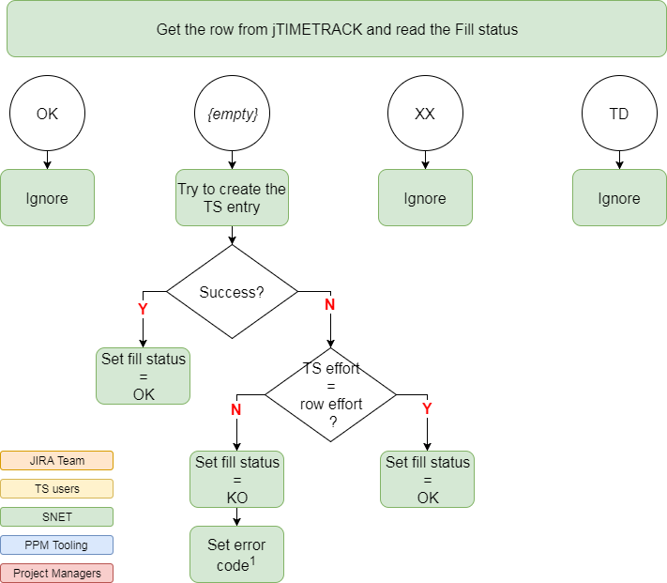

### Error codes (1)

This list of error causes will be completed and maintained by Sciforma when new errors will pop-up.

|  |  |  |
| --- | --- | --- |
| Err Code | Message | Happens when… |
| 10 | Unable to create TS entry on Validated data | We try to create a timesheet entry on one existing value, already validated. |
| 11 | Unable to create TS entry on Reviewed data | We try to create a timesheet entry on one existing value, already reviewed. |
| 12 | Self-assignment not allowed | We try to create a new timesheet line and the task’s field “Allow Mt Work Add” is set to false (self-assignments not accepted). |
| 13 | Task closed | We try to create a timesheet entry on a closed task |
| 14 | Resource not granted | The resource isn’t part of the work-package’s performing organization (if applicable) |
| 15 | Not project member | The resource isn’t part of the project team |
| 16 | Parent Task | We try to create a timesheet entry on a parent task |
| 17 | Locked Timesheet Period | We try to create a timesheet at a date which is already closed for the resource’s organization. |
|  |  | *To be completed if needed* |

### Fixes (1)

Depending on the nature of the problem the required changes will be processed (rework, capture again, submit) manually by the resource’s line manager in Sciforma. In case of problems, escalation will be done to PPM Tooling.

### Error codes (2)

This list of error causes will be completed and maintained by Sciforma when new errors will pop-up.

|  |  |  |
| --- | --- | --- |
| Err Code | Message | Happens when… |
| 20 | Unable to delete TS entry on Validated data | We try to delete a timesheet entry which is already validated. |
| 21 | Unable to delete TS entry on Reviewed data | We try to create a timesheet entry which is already reviewed. |
|  |  | To be completed… |
|  |  |  |

### Fixes (2)

Depending on the nature of the problem the required changes will be processed (rework, capture again, submit) manually by the resource’s line manager in Sciforma. In case of problems, escalation will be done to PPM Tooling.

## Integration – step #2: TS submission

### Purpose

This part of the program, which can be launched on request too, is to submit the timesheets of the users present in the data view jTIMETRACKING and update accordingly the records of the data view jSUBMISSION.

If the submission succeeds the **submission status** is set to OK, otherwise it is set to KO and both **submission error code** and **message** are filled with the relevant data.

### Process

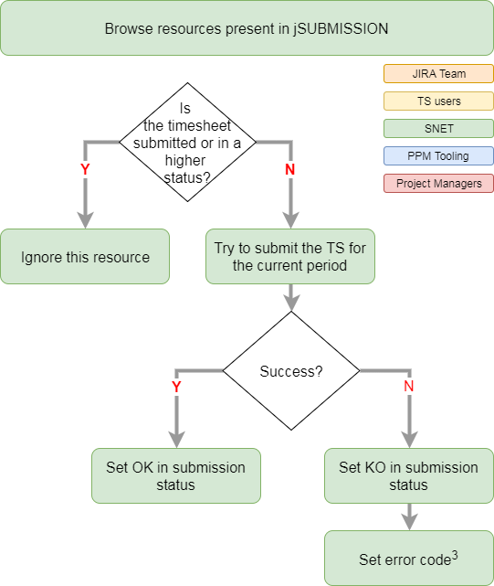

### Error codes (3)

This list of error causes will be completed and maintained by Sciforma when new errors will pop-up.

|  |  |  |
| --- | --- | --- |
| Err Code | Message | Happens when… |
| 30 | Time Entry Set Problem | The captured timesheet doesn’t meet the requirements of the Time Entry Set |
| 31 |  |  |
|  |  | To be completed… |
|  |  |  |

### Fixes (3)

Depending on the nature of the problem the required changes will be processed (rework, capture again, submit) manually by the resource’s line manager in Sciforma. In case of problems, escalation will be done to PPM Tooling.

## Quotation

The table below gives a list of the main works to be performed and the associated costs. Each team must fill the part under its responsibility.

|  |  |  |  |  |
| --- | --- | --- | --- | --- |
| **WID** | **Work** | **Team** | **Cost estimation** | **Comments** |
| 3.1 | Sending the Timesheet file to Sciforma | JIRA | N/A |  |
| 3.2 | Data reception and filling of the data views in Sciforma | SNET |  | jTIMETRACKING and jSUBMISSION |
| 3.3 | Creation of the initial checking report for Timesheet data | PPM Tooling | 2 days |  |
| 3.4 | Prevent “JIRA resources” to edit TS from Sciforma | PPM Tooling | 3 days |  |
| 3.5 | Integration API program – step 1 filling | SNET |  |  |
| 3.6 | Integration API program – step 2 submission | SNET |  |  |
| 3.7 | Creation of the resource submission report | PPM Tooling | 1 day |  |
| 3.8 | Update of the rework process in Sciforma | PPM Tooling | 3 days |  |
|  |  |  |  |  |

# Global Quotation

To be completed.

# Opportunities & Risks analysis

This interface is meant to replace a solution that already exists and works. In order to have a fair view of the pros and cons we identified the below list of opportunities and risks.

## Opportunities

* R&D teams won’t have to switch tool to track time and will remain in the day-to-day JIRA.
* R&D teams will directly capture time against user stories and won’t bother to know to what Business Initiative (AXIN) it is linked to.
* As defined above, the interface will allow keeping the same level of granularity of TS as currently: timesheet captures will fall under Business Initiatives as today.
* The fact that JIRA knows the list of user stories each user worked on recently will also highly facilitate the timesheet fulfillment for a squad member

Thus, any current project monitoring activity in SCIFORMA will remain the same.

Entering timesheets in JIRA will enhance:

Project monitoring as JIRA automatic dashboards will show delays, scope change and cost variance with respect to baselines

Financial indicators as JIRA automatic dashboards will show CAPEX projection vs actuals, at tribe or project levels

The possibility to have cross platform financial indicators through JIRA automatic dashboards that read seamlessly from any initiative within group-wide JIRA Techno instance

## Risks

Dispatching a seamless and integrated process between 2 tools will introduce new issues to keep the same level of working.

* Team Managers will have to check and ensure that each new BI will be created and linked into the 2 systems.
* Due to the disintegration of the process, the validation of TS will take more time and the financial closing might be delayed.
* The preparation, the follow-up of readiness and the management of errors might create administrative work for the JIRA Team and the R&D Line Managers. Could be worst if the Rework is integrated to this process.
* As previously said we will spend money to replace an existing solution that works.
* Not integrated anymore, the timesheet rework process will take place over 2 interfaced tools and by design will take a longer time to be completed.
* Finance requested a process to ensure the freeze of the timesheet period at a given time. Late captures are delaying the End of Month Closing and the idea was to prevent them. This process requires 100% of the timesheets being captured in Sciforma (R&D being one of the systematically late entries). Building the interface with JIRA will make this process more complex.

Non-agile working mode for this JIRA-Sciforma interface increases the chance of delay and tunnel effect with unknown unknowns* and resulting in additional project costs

*[unknown unknowns]: unexpected or unforeseeable conditions, which pose a potentially greater risk simply because they cannot be anticipated based on past experience or investigation